Lab 4 Tasks
Task 1:
#include <iostream>
using namespace std;

int main() {
const int SIZE = 10;
int arr[SIZE];

cout << "Enter 10 integers: ";
for (int i = 0; i < SIZE; i++) {
cin >> arr[i];
}

cout << "\nArray before sorting: ";
for (int i = 0; i < SIZE; i++) {
cout << arr[i] << " ";
}
cout << endl;

for (int i = 0; i < SIZE - 1; i++) {
bool swapped = false;

for (int j = 0; j < SIZE - i - 1; j++) {
if (arr[j] > arr[j + 1]) {
int temp = arr[j];
arr[j] = arr[j + 1];
arr[j + 1] = temp;
swapped = true;
}
}

if (!swapped) {
cout << "Early termination after " << i + 1 << " passes!" << endl;
break;
}
}

cout << "Array after sorting: ";
for (int i = 0; i < SIZE; i++) {
cout << arr[i] << " ";
}
cout << endl;

return 0;
}
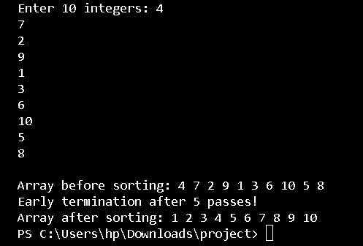
Task 2:
#include <iostream>
#include <string>
using namespace std;

int main() {
cout << "=== TASK 1: Selection Sort for 5 Cities ===\n";
const int SIZE = 5;
string cities[SIZE];

cout << "Enter 5 city names: ";
for (int i = 0; i < SIZE; i++) {
cin >> cities[i];
}

cout << "\nCities before sorting: ";
for (int i = 0; i < SIZE; i++) {
cout << cities[i] << " ";
}
cout << endl;

for (int i = 0; i < SIZE - 1; i++) {
int min_index = i;
for (int j = i + 1; j < SIZE; j++) {
if (cities[j] < cities[min_index]) {
min_index = j;
}
}
if (min_index != i) {
string temp = cities[i];
cities[i] = cities[min_index];
cities[min_index] = temp;
}
}

cout << "Cities after sorting: ";
for (int i = 0; i < SIZE; i++) {
cout << cities[i] << " ";
}
cout << endl;

cout << "\n=== TASK 2: Count Swaps in Selection Sort ===\n";
int arr[] = {29, 10, 14, 37, 13};
int swap_count = 0;

cout << "Array before sorting: ";
for (int i = 0; i < SIZE; i++) {
cout << arr[i] << " ";
}
cout << endl;

for (int i = 0; i < SIZE - 1; i++) {
int min_index = i;
for (int j = i + 1; j < SIZE; j++) {
if (arr[j] < arr[min_index]) {
min_index = j;
}
}
if (min_index != i) {
int temp = arr[i];
arr[i] = arr[min_index];
arr[min_index] = temp;
swap_count++;
}
}

cout << "Array after sorting: ";
for (int i = 0; i < SIZE; i++) {
cout << arr[i] << " ";
}
cout << endl;

cout << "Number of swaps performed: " << swap_count << endl;

return 0;
}
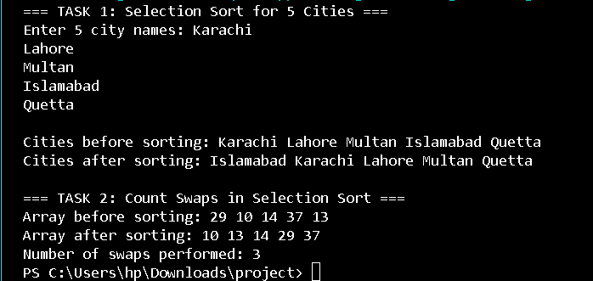
Task 3:
#include <iostream>
using namespace std;

int main() {
cout << "=== INSERTION SORT (ASCENDING ORDER) ===\n";
int marks[] = {15, 2, 78, 25, 63};
const int SIZE = 5;

cout << "Original marks: ";
for (int i = 0; i < SIZE; i++) {
cout << marks[i] << " ";
}
cout << endl;

for (int i = 1; i < SIZE; i++) {
int key = marks[i];
int j = i - 1;

while (j >= 0 && marks[j] > key) {
marks[j + 1] = marks[j];
j--;
}
marks[j + 1] = key;
}

cout << "Sorted (ascending): ";
for (int i = 0; i < SIZE; i++) {
cout << marks[i] << " ";
}
cout << endl;

cout << "\n=== INSERTION SORT (DESCENDING ORDER) ===\n";
int numbers[] = {15, 2, 78, 25, 63};

cout << "Original numbers: ";
for (int i = 0; i < SIZE; i++) {
cout << numbers[i] << " ";
}
cout << endl;

for (int i = 1; i < SIZE; i++) {
int key = numbers[i];
int j = i - 1;

while (j >= 0 && numbers[j] < key) {
numbers[j + 1] = numbers[j];
j--;
}
numbers[j + 1] = key;
}

cout << "Sorted (descending): ";
for (int i = 0; i < SIZE; i++) {
cout << numbers[i] << " ";
}
cout << endl;

return 0;
}
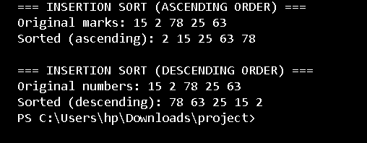
Task 4:
#include <iostream>
using namespace std;

void shellSort(int arr[], int n) {
int gaps[] = {10, 5, 3, 2, 1};
int gap_count = sizeof(gaps)/sizeof(gaps[0]);

cout << "Gap sequence used: ";
for (int i = 0; i < gap_count; i++) {
cout << gaps[i] << " ";
}
cout << endl;

for (int gap_index = 0; gap_index < gap_count; gap_index++) {
int gap = gaps[gap_index];
cout << "Using gap " << gap << ": ";

for (int i = gap; i < n; i++) {
int temp = arr[i];
int j;
for (j = i; j >= gap && arr[j - gap] > temp; j -= gap) {
arr[j] = arr[j - gap];
}
arr[j] = temp;
}

for (int i = 0; i < n; i++) {
cout << arr[i] << " ";
}
cout << endl;
}
}

int insertionSort(int arr[], int n) {
int shifts = 0;
for (int i = 1; i < n; i++) {
int key = arr[i];
int j = i - 1;

while (j >= 0 && arr[j] > key) {
arr[j + 1] = arr[j];
j--;
shifts++;
}
arr[j + 1] = key;
if (j != i - 1) shifts++;
}
return shifts;
}

int main() {
cout << "=== SHELL SORT (20 random numbers) ===\n";
int random_nums[] = {45, 23, 78, 12, 89, 56, 34, 67, 90, 11,
32, 65, 87, 43, 76, 21, 54, 98, 33, 19};
const int SIZE = 20;

cout << "Original array: ";
for (int i = 0; i < SIZE; i++) {
cout << random_nums[i] << " ";
}
cout << endl << endl;

shellSort(random_nums, SIZE);

cout << "\nFinal sorted array: ";
for (int i = 0; i < SIZE; i++) {
cout << random_nums[i] << " ";
}
cout << endl;

cout << "\n=== COMPARISON: SHELL SORT vs INSERTION SORT ===\n";
int arr1[] = {50, 40, 30, 20, 10};
int arr2[] = {50, 40, 30, 20, 10};
const int SMALL_SIZE = 5;

cout << "Input array: ";
for (int i = 0; i < SMALL_SIZE; i++) {
cout << arr1[i] << " ";
}
cout << endl;

int shell_shifts = 0;
int gaps[] = {5, 3, 2, 1};
for (int gap_index = 0; gap_index < 4; gap_index++) {
int gap = gaps[gap_index];
for (int i = gap; i < SMALL_SIZE; i++) {
int temp = arr1[i];
int j;
for (j = i; j >= gap && arr1[j - gap] > temp; j -= gap) {
arr1[j] = arr1[j - gap];
shell_shifts++;
}
arr1[j] = temp;
if (j != i) shell_shifts++;
}
}

int insertion_shifts = insertionSort(arr2, SMALL_SIZE);

cout << "Shell Sort shifts: " << shell_shifts << endl;
cout << "Insertion Sort shifts: " << insertion_shifts << endl;

if (shell_shifts < insertion_shifts) {
cout << "Shell Sort is faster (fewer shifts)" << endl;
} else if (shell_shifts > insertion_shifts) {
cout << "Insertion Sort is faster (fewer shifts)" << endl;
} else {
cout << "Both have same number of shifts" << endl;
}

return 0;
}
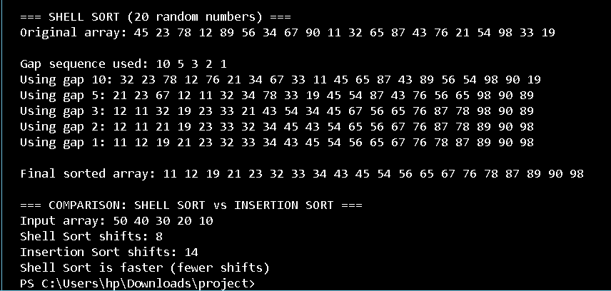
Task 5:
#include <iostream>
using namespace std;

void combSort(int arr[], int n) {
int gap = n;
bool swapped = true;
while (gap != 1 || swapped) {
gap = (gap * 10) / 13;
if (gap < 1) gap = 1;
cout << "Gap: " << gap << endl;
swapped = false;
for (int i = 0; i + gap < n; i++) {
if (arr[i] > arr[i + gap]) {
int temp = arr[i];
arr[i] = arr[i + gap];
arr[i + gap] = temp;
swapped = true;
}
}
}
}

void bubbleSort(int arr[], int n) {
for (int i = 0; i < n - 1; i++) {
for (int j = 0; j < n - i - 1; j++) {
if (arr[j] > arr[j + 1]) {
int temp = arr[j];
arr[j] = arr[j + 1];
arr[j + 1] = temp;
}
}
}
}

int main() {
int arr1[] = {9,8,7,6,5,4,3,2,1};
int arr2[] = {9,8,7,6,5,4,3,2,1};
int n = 9;
cout << "Comb Sort:" << endl;
combSort(arr1, n);
cout << "Sorted Array: ";
for (int i = 0; i < n; i++) cout << arr1[i] << " ";
cout << endl;
cout << "Bubble Sort:" << endl;
bubbleSort(arr2, n);
cout << "Sorted Array: ";
for (int i = 0; i < n; i++) cout << arr2[i] << " ";
cout << endl;
}

/*For the reverse-sorted array {9,8,7,6,5,4,3,2,1}, Comb Sort is faster than Bubble Sort,
because it quickly moves small elements toward the front using larger gaps in early passes,
while Bubble Sort only swaps adjacent elements slowly.*/
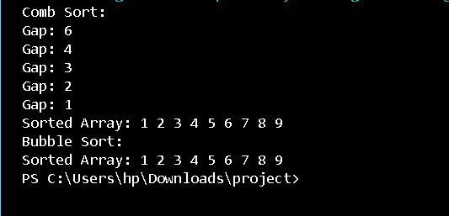
Task 6:
#include <iostream>
using namespace std;

int main() {
int arr[] = {101, 105, 110, 120, 135, 150};
int n = 6;
int key;
cout << "Enter roll number to search: ";
cin >> key;

int low = 0, high = n - 1;
int comparisons = 0;
bool found = false;

while (low <= high) {
int mid = (low + high) / 2;
comparisons++;
if (arr[mid] == key) {
found = true;
break;
}
else if (arr[mid] < key) {
low = mid + 1;
}
else {
high = mid - 1;
}
}

if (found)
cout << "Roll number found" << endl;
else
cout << "Roll number not found" << endl;

cout << "Number of comparisons: " << comparisons << endl;
}

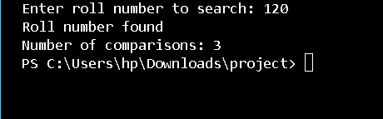
Task 7:
#include <iostream>
using namespace std;

int interpolationSearch(int arr[], int n, int key, int &comparisons) {
int low = 0, high = n - 1;
comparisons = 0;

while (low <= high && key >= arr[low] && key <= arr[high]) {
comparisons++;
if (low == high) {
if (arr[low] == key) return low;
return -1;
}
int pos = low + ((double)(high - low) / (arr[high] - arr[low])) * (key - arr[low]);
if (arr[pos] == key)
return pos;
if (arr[pos] < key)
low = pos + 1;
else
high = pos - 1;
}
return -1;
}

int main() {
int arr[] = {10,20,30,40,50,60,70,80};
int n = 8;
int key;
cout << "Enter price to search: ";
cin >> key;

int comparisons;
int result = interpolationSearch(arr, n, key, comparisons);

if (result != -1)
cout << "Price found at position " << result << endl;
else
cout << "Price not available" << endl;

cout << "Number of comparisons: " << comparisons << endl;
}

